19CSE204 OBJECT ORIENTED PROGRAMMING

CASE STUDY REPORT

TITLE:

ELECTRIC BILL MANAGEMENT SYSTEM

By

Sakthi Vikkraman R

Hariharan M

Uvan Shankar SJ

Amrithesh PJ

# Problem Statement

This project is related to bill payment system. The system provides details of electricity consumed by the customers. The admin of the electricity board generated bills every month based on the electricity consumed by customers in terms of the number of UNITS. The bill is generated by calculating the units of electricity as the difference from the current total number of units to the previous month’s total units. The resultant units are multiplied by the cost of each unit that is fixed by the board. The admin of the electricity board has details of customers in operating range (like customer number, address, earlier reading, current reading, the charge per unit, etc.). The customer can log in to the board’s site with his number and be able to view all the past transaction details, current amount to be paid, number of units sed, arrears, last date to pay the bill, etc. The admin can verify the bill status of customers. If the bill is not paid over a specified period an alert will be sent to the customer beyond which the connection will be dropped. The status of the customer’s bill can be verified by the admin and be updated.

# Actor

* USER
* ADMIN

# TASK LIST

User:

* Add register details
* Login through user portal
* Gets notified by announcement and bills
* Pays bill in given duration
* Provides feedback
* Requests in customer care

Admin:

* Add register details
* Logins through admin portal
* Updates readings of users
* Provides announces regularly
* Checks customer care and feedback regularly
* Update bill and current tariff values

# LEVELS OF USE CASE:

* Description
* Actors
* Trigger
* Precondition
* Basic flow
* Alternates
* Exception
* Postconditions
* Stakeholders

# CONCEPTUAL CLASS LIST:

* Register
* Login
* Admin
* User
* Bill
* Current Tariff
* Readings
* Announcement
* Database
* Customer care
* Feed back

# From Conceptual Class:

## 1.Abstract class:

Nil

## 2.Interface:

Payment method

## 3.Inheritance Relationship:

Register Login

Bill Payment

## 4.Static Variable:

Bill

+Billno : int

Announcement:string

Feed back:string

## 5.Aggregation:

Bill Reading

## 6.Composition:

User Customer Care

Bill Payment

Bill Current Tariff

## 7.Dependancies:

User Admin

# CLASS DIAGRAM

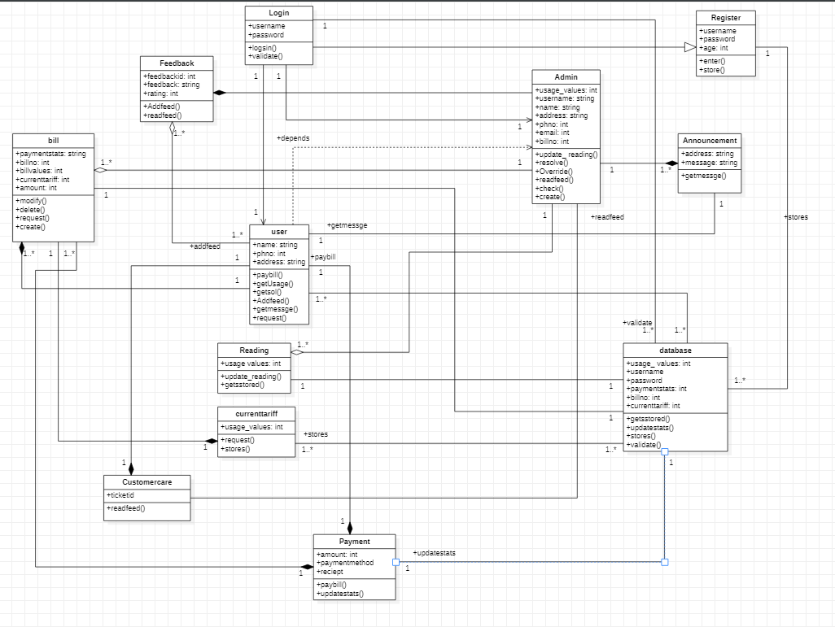

# TASK DONE TABLE:

|  |  |
| --- | --- |
| NAME | TASKS DONE |
| Sakthi Vikkraman R | Use case, object diagram, time sequence diagram of payment, database, bill, current tariff and cover ppt |
| Uvan Shankar SJ | Use case, object diagram, time sequence diagram of Announcement, Feedback, Login and Register. |
| M Hariharan | Use case, object diagram and time sequence of Admin, User, Reading and Customer care. |
| Amritesh P J | Class Diagram |